Error 1 : Sometimes, the following error could occur:

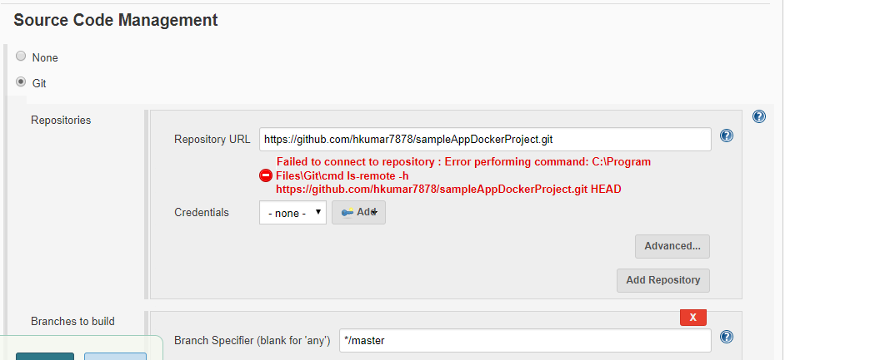

Solution: Navigate to Manage Jenkins -- > Global Tool Configuration and set the path of Git .exe as follow

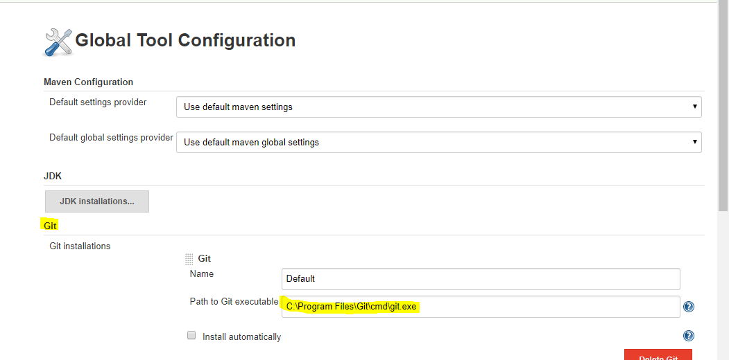

After this configuration, the error was successfully removed.